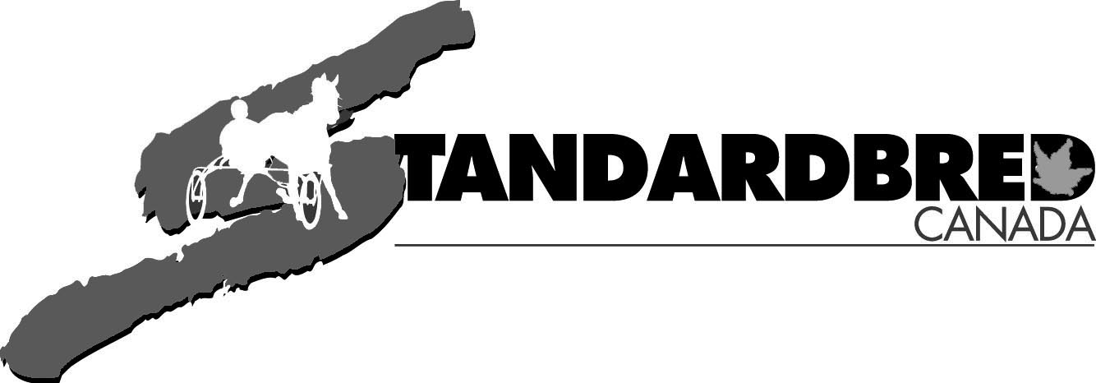
STAKE PAYMENT FORM (GENERIC)

- This form is to be used for stakes administered by Standardbred Canada only.
- Standardbred Canada sends payment notices to the first registered owner of eligible horses (SC Stakes only) via mail or email.

NAME OF HORSE: REGISTRATION #: SEX:

SIRE: __________________________ DAM:____________________________ AGE:_____________ GAIT:__________________
By remitting this form, I hereby nominate/sustain the above-named Standardbred to the indicated stake events.

Fill in the events name, payment date and amount for each stake payment you are making for your horse.

NAME OF STAKE: PAYMENT DUE DATE: $ AMOUNT:

Standardbred Canada sends stake payment notices to the owner listed first on the ownership of eligible horses approximately one month prior of the due date.

This form is to be used only if you wish to mail your payments and did not receive a form or misplaced it.

TOTAL REMITTED: __________________________________

OWNER NAME: ___________________________________________________

OWNER SIGNATURE: _____________________________________________

Payments can be made ONLINE with a credit card on the SC website.
www.standardbredcanada.ca/eshop/services

If mailing, please include this form and make cheques payable to Standardbred Canada.
Acceptable forms of payment by mail are cheque or money order.

